**The Merton Initiative: Towards a Global Observing System for the Human Environment**

May 2012

***Acknowledgement***

This report was developed by a group supported by the International Geosphere Biosphere Programme (IGBP), the National Center for Atmospheric Research, the European Space Agency and facilitated by the Analysis, Interpretation and Modeling of the Earth System (AIMES) project of the IGBP. The report stems from a meeting held at Merton College, Oxford University in September 2011 to follow-up on initial discussions at the IGBP Scientific Committee (SC) meeting held at Grenoble in 2009.

Contents

1.0 Introduction to Integrated Observations 3

2.0 Current approaches and relationship to ongoing global programmes 5

3.0 Findings and lessons learned 6

3.1 Coverage of global observing systems 7

3.2 Interoperability and scale pose a major challenge. 8

3.3 The integration of space-based observations with ground-based measurements 10

3.4 Harmonization of data products 10

3.5. Maximizing return on investment 11

3.6 The need for partnerships 11

3.7. Data policy 11

3.8 Supporting the scientific community 11

4.0 Role of Modeling 12

5.0 Key Questions 13

5.1 Definition of Research Questions 13

5.2 Detection and Attribution 13

5.3 Analysis and Forecast 14

5.4 Scenario Building and Decision Support 14

6.0 Requirements 15

7.0 Implementation Options 16

References 17

Appendix A. The Merton Initiative – Participants 19

Appendix B. List of Observations Groups and Systems 20

# 1.0 Introduction to Integrated Observations

As Earth System science advances and matures, it must be supported by robust and integrated observation systems (Box 1). A number of important, recent documents call for significant changes to global observing systems to meet the scientific and practical challenges of the 21st Century (NRC 2010, Ciais et al. 2010, Birdsey et al. 2009). Major challenges to current observing systems were highlighted in these recent documents, furthering the need to design new approaches.

In 2010, at the annual meeting of the IGBP Steering Committee, a working group composed of IGBP participants, as well as representatives from the other ESSP projects, ESA and other key partners reviewed the status of observing systems and networked observations in the IGBP family of projects. This group concluded that for IGBP’s increasingly integrative and ambitious programs, significant gaps existed in the current portfolio of activities. The vast majority of systems and protocols were within Core Project scope, and developed around a set of Earth System component (atmosphere, ecosystems, coastal zones, oceans etc) science issues. However all present felt that increasingly their science was taking them into a new domain of research where Earth System component *interactions*, including with the human sphere, were becoming more significant. Equally, there was great concern that many interactions between the bio-physical and chemical Earth System processes and human systems were not well captured in current systems. Spatial gaps exist in under-observed parts of the land, atmosphere and oceans as a result of funding sources, logistical difficulties and existing collaborations. Finally, opportunities to add value by close coordination of in situ and space-based observations are still being missed, even when such coordination could occur at relatively low cost.

IGBP, in consultation with other ESSP partners, GEO/GEOSS and other key organizations has undertaken a study, based mainly on IGBP’s two decades of experience in mobilizing field campaigns, observing networks and other programs, to respond to this gap analysis. This document reports on that activity, and is intended to capture issues and recommendations arising largely (though certainly not exclusively) from the IGBP’s experience base. This study is intended as a report on that experience as a number of developments unfold. First, GEOSS continues to advance the science of observation, and is increasingly able to implement new ideas emerging from its open and consultative processes (many of the participants in this project also are involved in GEOSS initatives). Second, the international programs are responding to the Belmont Forum initatives and are in a phase of evaluation of priorities for the future. Future Earth is in planning and this document contributes to identifying observing and process study opportunities and requirements for its new areas of focus. This document is intended as input into all of those processes, reporting on a gap analysis and recommendations gained from IGBP’s own experience and drawing on its partners. This report was drafted during a workshop held at Merton College, Oxford in the UK.

Integration with observations of human drivers, responses, and interactions with the environment, together with behavioral and decision-oriented understanding is critical to the future of Earth System Science. Current observing networks were, for the most part, not designed to couple natural or biogeophysical observations with social and human networks and methodologies. Achieving an appropriate level of integration across platforms and domains will require overcoming several significant and often compounding issues associated with scale, scope, location, and data compatibility. Human and biogeophysical systems are scaled quite differently in time and space, and the natural scales of these two spheres are not always considered in designing observation systems. Many of today’s observation systems were designed with specific domain objectives in mind and, while they provide useful data for a number of applications (e.g., merchantable timber volume), they are often mismatched with other platforms, resulting in a general lack of integration and synergy. Typically, current systems are optimized for discrete tasks within individual domains or disciplines and are rarely co-located with other systems that, under an Earth Systems perspective, would be deemed complimentary and advantageous.

*Box 1: Integration of Biological, Environmental and Human Observations*

*Observing systems are used to quantify biological and environmental condition and change, and include repeated measurements of biological, biogeochemical, physical, hydrologic and meteorologic parameters of interest. Long-term observations, e.g. over decades, are used to elucidate trends in biological and environmental condition. Observations of the human dimension need to be part of the analysis of change in condition. This includes human appropriation of primary production and its drivers (population density and distribution, associated land-use/land cover change. e.g., patterns of forest clearing for agriculture), human wellbeing, and proposed or implemented policy actions. Integration of the observing systems can predict future biological outcomes of policy actions and land-use patterns.*

IGBP’s mandate requires addressing the mutual impacts and feedbacks between humans and the biosphere, global biogeochemical cycles and the physical climate system. The IGBP collaborates with the other Earth System Science programmes (WCRP, Diversitas and IHDP) and our Earth System Science Partnership (ESSP) to understand the interactions of human systems with, on the one hand, the diversity of life, and on the other, the physical, chemical, biological and hydrological processes of the geophysical Earth. In 2009, in Grenoble, France, IGBP and partner program scientists identified a specific need for a coordinated observing system to quantify and qualify coupled Earth System processes including direct human impacts, or net feedbacks between human systems and biogeophysical processes. Detecting, diagnosing, and forecasting interactions between human-environment processes are at the frontier of trans-disciplinary science. The Grenoble meeting identified improving observations of the coupled human-environment process as a critical need. The Grenoble group went on to note that a coordinated observing system that captured the coupled human-environment system also generated other requirements, including a need to better observe human-influenced interactions between the geophysical domains (atmosphere, land, ocean) and to improve the relationships between *in situ* and remote observing systems whereby cross-scale boundaries could be investigated, including mechanistic extrapolation (as appropriate) to regional and ultimately, planetary scales.

*Current and new systems must be better integrated into a planetary observatory that provides critical, long-term data and information about our changing planet, including observations of critical human processes.*

Following on this, the Merton Initiative group (see Appendix A for participant list) believes a new approach is needed to build the scientific knowledge and scholarship required to understand and manage the Earth system. Current and new observing systems must be better integrated into a global observatory that provides critical, long-term data and information about our changing planet, including observations of critical human processes. Currently, environmental data are collected in one of two modes. The first is a *research* mode, designed and funded to address relatively specific questions in a defined span, including most principal investigator studies and many space missions. The second is a *monitoring* mode, where specific long-term observations are collected for detecting trends. Occasionally, support for research studies is stitched together for long periods of time to create a hybrid system.

There are a number of issues with current observing systems. One is deficiencies in the long-term record. A recent Global Earth Observation System of Systems (GEOSS) work plan identifies needs within important observing systems, gaps between them and requirements for increased interoperability between question- and domain-specific systems (e.g. expected gaps in Landsat temporal coverage, in spite of Landsat Data Continuity Mission; NRC 2010). Similar issues arose in a review of IGBP observing networks at the 2009 SC meeting.

Secondly, Earth System Science requires *globally* integrated data. Yet, currently, many distributed programs represent a pattern of heavy investment in specific marine, ecosystem, social and climate regimes, with uneven sampling effort distributed over the globe or even continents. It is widely recognized that certain ecosystems and land cover types are undersampled (Martin et al. 2012). These asymmetries result in significant data bias with substantial analytical gaps, which may ultimately signify that additional as-yet unknown biases also exist. For example, Lee et al. (2011) called for new climate monitoring strategies that better represent temperature changes in forests for modeling land-use change effects on climate. Because surface temperature observations are made in grassy fields with biophysical properties of cleared land, they do not accurately represent the surface meteorological state of 30% of the terrestrial surface covered by forests. Biases as large as 8oK were observed in the diurnal temperature range between paired station and forest tower sites. Teuling et al., (2010) also reported strong contrasts in biosphere-atmosphere interactions between land-cover types, in particular during extreme weather conditions. The issue of regional gaps is addressed in Section 3.1 below.

A final issue is that observations that quantify changes in the rates or magnitude of Earth-system forcings and their impacts are rarely co-located, increasing the challenge of quantifying attribution and their associated feedbacks. Furthermore, the data collected may at best be proxies for the variables of interest. Although the research community has been adept at repurposing observations for a variety of uses, it has become increasingly important to have systems that are deliberately designed to address complex, integrative questions and to support research on pressing societal concerns.

In many research communities, the need for a third mode of support is recognized. Many of the physical sciences require large-scale facilities that, owing to the magnitude of the investment, are operated for long periods of time. These include telescopes and accelerators in the physical sciences. The environmental sciences include some facilities that are supported in the long-term, but these are mainly *platforms* for research, such as research vessels or aircraft, and not observing systems producing long-term science data in-and-of themselves. In the United States, the Ocean Observing Initiative (OOI) and the National Ecological Observatory Network (NEON) and in Europe the Integrated Carbon Observation System (ICOS) are demonstrations of a new paradigm. These *environmental observatories* are being built in response to the requirements for observations over vast areas, observing processes that evolve over decades, and requiring costly instrumentation and operations. Yet for all their promise, these observatories remain but demonstration projects. We need observation systems that are operational for many decades and are global in extent, from which full suites of measurements can be synthesized regularly in order to produce regular global environmental report cards linking environmental changes with human activities and responses to those changes.

The current global observing system is an amalgam of long-term monitoring networks and research activities. The Merton Initiative argues that this excellent network of basic observations should be complemented by a **Global Observing System for the Human Environment (GOSHEN))*,*** an international, long-term and distributed system of advanced and highly integrated observations, designed and purpose-built to study the dynamics of the human-environment system. GOSHEN should be carefully designed and implemented through international collaboration and supported in the long-term (2-3 decades) by agreements similar to those that support current international science facilities in space, physics and astronomy, although as a distributed global facility, the mode of construction and support may be quite different from traditional unitary facilities. It should include human, physical, and biological measurements, fill critical gaps in observational coverage, and be scalable and adaptable in response to increased understanding and identification of new science questions. Below, we discuss some of the issues and guidelines that might guide the development of a GOSHEN.

*The Merton Initiative proposes an international, long-term and distributed system of advanced and highly integrated observations, designed and purpose-built to study the dynamics of the human-environment system.*

# 2.0 Current approaches and relationship to ongoing global programmes

Currently, a range of observing strategies exist, together with a number of initiatives to link them together through cyber-infrastructure (e.g., GEOSS). A comprehensive survey of observing systems is well beyond the scope of this paper. Instead, we describe characteristics and lessons learned that can help guide the development of future fully integrated systems as well as building on existing structures through systems of systems.

A short, representative list of ongoing observing programmes related to the Earth system and human-environment interactions from Appendix B. This list, which is far from being comprehensive, gives a sense of the range of programs currently going on globally and regionally. Integrating these diverse activities is a great challenge, and despite the many programmes significant gaps remain in variables observed, regions and time scales.

GEOSS has defined a work plan, with the goal of both improving observing systems for Earth System components (such as those listed above), and linking component observing systems together more strongly. For example, quoting from the Draft 2012-2015 work plan, a key GEOSS Strategic Target calls for:

* *Coordinated planning and sustained operation of national, regional and global observing and information systems within an interoperability framework.*
* *Continual improvement in observations and information available to users through the transition of research outcomes and systems into operational use, and through an optimal mix of space-based, airborne and in-situ observing platforms.*
* *Increased efficiency in the operation of observational systems through convergence among global, regional and national facilities.*
* *Promote and coordinate surface- and space-based observing systems to provide long-term continuous observations of all components of the Earth System (atmosphere, ocean, terrestrial, ice, solid earth).*
* *Ensure that the Earth and its physical processes are monitored globally across spatial and temporal scales.*
* *Identify critical gaps in existing observational networks with particular focus on: the needs of developing countries, the need for continuity of observations, the need for increased advocacy of in- situ networks, and the potential benefits of enhanced observing systems.*

Within GEOSS’ broad remit, IGBP has identified a series of issues that, as an international Key Science Body can assist with, drawing on its experience in observing and quantifying processes associated with biogeochemical cycles, coupled human-natural systems such as land use and marine fisheries, and climate impacts. The GEOSS report targets societal benefit areas, and acknowledges the role of humans in the Earth System, but does not specifically address the direct observation of human systems. The coupled human-environment system and the maintenance of ecosystem services is a growing focus of IGBP and its core projects. In addition, recognizing the intimate connections between the IGBP foci, biodiversity and the human condition, IGBP convened colleagues from the other international global change programmes to join an effort to develop an observing strategy that more fully incorporates human observations.

# 3.0 Findings and lessons learned

The Merton group developed a number of findings to guide design discussions going forward. Many of these lessons learned reprise findings in other reports and are covered here for completeness. Others reflect the highly interdisciplinary nature of the Merton group.

## 3.1 Coverage of global observing systems

Coverage of global observing systems is highly variable in density and large regions of the planet are inadequately observed. Several examples make this clear. Figure 1 shows the coverage of the FLUXNET system for carbon fluxes, which is limited in its coverage of tropical and high altitude ecosystems, and weak in several major continental regions (Central Asia, Russia, Africa). This reflects the distribution of resources available for science, national funding policies and the natural tendency of researchers to work initially close to home, especially given the intensive nature of flux observations.

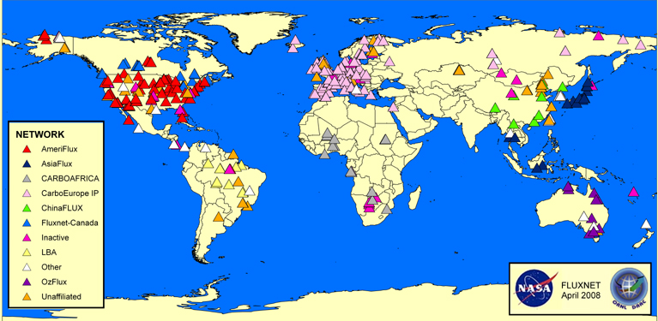

*Figure 1. Global FLUXNET distribution based on 2008 coverage. Note lack of instrumentation/ observations in much of Africa, India, northern Russia and much of the Middle East.*

Figure 2 shows the distribution of current ocean observatory initiative from the Surface Ocean-Lower Atmosphere Study (SOLAS) core project in the IGBP, and the proposed additional sites to provide minimal ocean coverage. Similar to land-based systems, the current ocean programme of integrated observations has significant gaps in coverage and the number of proposed or required new sites is significantly larger than the current array of observing sites and moorings (long-term unattended buoys).



*Figure 2. Operational and proposed sites for the IGBP Surface Ocean- Lower Atmosphere Study (SOLAS) Observatory,* Minimalist OceanSITES Interdisciplinary Network *(MOIN).*

Based on the review conducted by the Merton Initiative group, while data integration within and between human and biophysical observations is challenging globally, the tropics, high altitude systems, interior Eurasia, the Southern Ocean, Eastern Boundary Current and Major Estuarine coastal zones are examples of areas of special concern. The Merton Initiative group recommends that substantial effort be put into implementing components of an integrated Earth System observatory in critical under-observed regions of the land and oceans.

## 3.2 Interoperability and scale pose a major challenge.

Organizations within GEOSS and in the scientific community are making progress on reducing barriers to interoperability by making remote sensing data more accessible to the global community (e.g. free Landsat data), and producing datasets with metadata that are publically available on the web (e.g. AmeriFlux). As data barriers lower, conceptual challenges associated with the scale of observation become more evident. For example, human systems are often scaled differently from biogeophysical systems and generally do not correspond spatially or temporally. Another hurdle is quantifying sociological data that are qualitative or value-driven (e.g., institutions and governance systems), and often difficult to predict in the future (e.g., land-use change in countries with unstable political climate).

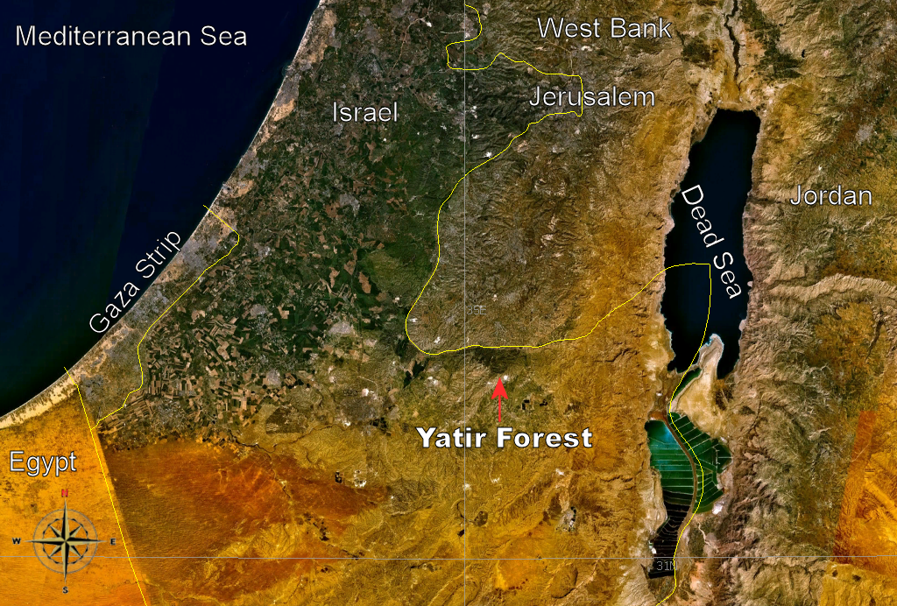

*Figure 3. MODIS image of the Yatir forest. In general, observations are located in geographic, or ecosystem-specific areas, however, management and human system processes are often constrained by socio-political boundaries.*

Many biogeophysical observing systems are guided by natural boundaries while human observations tend to follow administrative boundaries. Although efforts have been made by CIESIN, SAGE, and other groups to grid demographic and socioeconomic data from censuses and surveys, thereby facilitating integration with biophysical data, the units upon which these grids are based are often of coarse resolution, and the frequency of observations can be low. For example, censuses in many regions are infrequent (Figure 4), and the surveys that provide health and wellbeing data are conducted on a periodic basis for certain least developed countries, with insufficient spatial resolution to be able to localize wellbeing measurements (Figure 5). The Merton Initiative group recommends that future integrated observatories be scaled to be consistent with human systems (e.g., socio-political boundaries) while ensuring regular socioeconomic data collection.

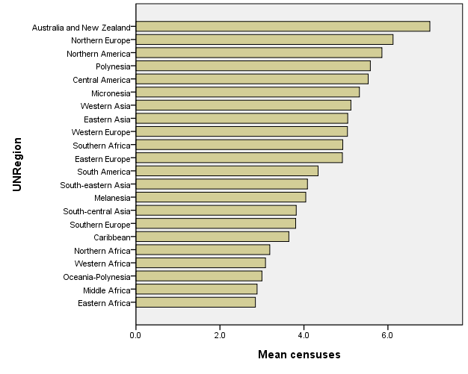

*Figure 4. Mean number of densuses from 1970-2010 by UN Region*

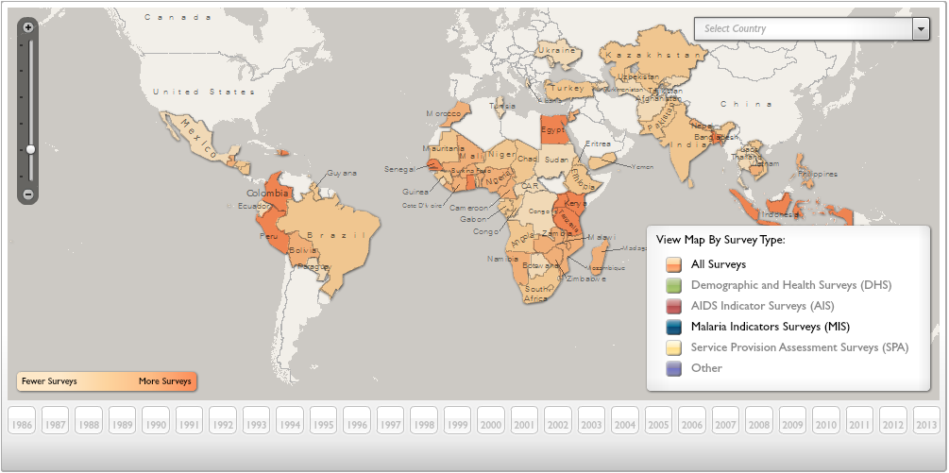

*Figure 5. Frequency of Demographic and Health Surveys*

## 3.3 The integration of space-based observations with ground-based measurements

The integration of space-based observations with ground-based measurements is a particular challenge that requires care in developing measurements and data products for cross calibration and validation of both and to provide a consistent interface to models. This must be addressed to allow the use of satellite products to integrate across scales in natural and human system studies. To achieve effective integration, structural as well as institutional challenges must be addressed. For example, it is clear that the Space Agencies need to incorporate validation of products generated by Earth observing sensors launched for estimation of specific essential climate variables as a fundamental part of any mission rather than an optional ‘extra’. Some of the biggest challenges we face are inconsistencies in definitions, measurement techniques, data reporting (variables and units), and calibrations despite common variable names leading to a global lack of traceability in measurements. Existing and planned observing systems should augment core measurements with key calibration and validation data to enable the coordinated and rigorous use of space-based observations.

## 3.4 Harmonization of data products

The diverse set of current observing systems produces a long list of data products and often uses divergent protocols, standards and sampling design to produce apparently similar data products. For example, GEO-Forest Carbon Tracking (GEO-FCT) aims to develop standard measurement protocols, but there are tiers of options from which to chose, depending on capabilities of different countries, limiting global synthesis of data. This adds complexity to integrating data across nations, between disciplines and between domains (land, atmosphere, oceans, human systems). While a degree of customization of observations to make them fit for the purpose they are intended within their programme is both inevitable and desirable, traceability to a set of common high-level protocols and standards is becoming increasingly important. Defining the information required, and appropriate standards for measurements, allows groups to develop local protocols that are appropriate for the local conditions, and add the additional measurements needed to answer the key questions. For example, in stable landscapes, eddy covariance flux measurements may be sufficient to define a local carbon balance, where in a fire-dominated ecosystem, fire frequency could be the critical determinant of carbon balance. Beyond improving the informatics of data integration, the MI group recommends a global effort to improve data-level interoperability by identifying a core list of critical human-environment variables and development measurement standards and protocols for these variables (e.g. Bombelli et al. 2009 Essential Climate Variables, Law et al. 2009 Protocols for vegetation sampling and data submission).

## 3.5. Maximizing return on investment

Complex observing systems represent significant initial investment, but also increase (or decrease?) in cost and gain value with time. Care and effort should be expended in their design in order to maximize the scientific return on investment. Experience shows that a conceptual model of the system being observed, linked to the core questions, is critical for identifying the right variables to observe, and the required scale, frequency, extent and accuracy of measurements (cite Lindenmayer and Likens, Charney, etc). The Merton initiative group recommends that conceptual and numerical models be used in the design of future human-environment observing systems.

*The Merton Initiative group recommends that conceptual and numerical models be used in the design of future human-environment observing systems.*

## 3.6 The need for partnerships

For an international observatory to succeed, a strong partnership is required between the international community, and scientists and stakeholders, including decisionmakers (e.g., resource managers) and policy communities. While balancing the requirements of local stakeholders and the global scientific community can be difficult, without this partnership, in-country observatories cannot be sustained. Building enduring global observatories requires real partnership between the local and global communities and mutual agreement on requirements.

## 3.7. Data policy

For a globally-distributed network of measurements to succeed as an Earth System observatory, a strong data sharing and free and open access to data policy is required, together with international standards for metadata describing uncertainty and traceability. The Merton Initiative group recommends adoption of the GEO Data Sharing Principles.

## 3.8 Supporting the scientific community

A global environmental observing network must support a wide variety of users, including scientific specialists, interdisciplinary researchers, students and teachers and policy and management decision-makers. In order to do this, it is not sufficient to simply collect data and make it available. It is essential to identify the information needed by the key stakeholder communities, the approach or algorithm required to produce that information from the data, and to produce the required information in a credible, well-documented and regular fashion.

# 4.0 Role of Modeling

Modeling is central to observing system design and observatory design generally begins with the development of a conceptual model of the system being observed. A conceptual model is a representation of how system components and processes interact and influence one another. A conceptual model helps identify, in a qualitative way, the main state variables and parameters of the system that govern its behaviour. In some cases, an observatory might be designed around multiple conceptual models (alternate working hypotheses) or even to distinguish between alternate conceptual models. A conceptual model is necessary to guide ongoing observations and analyses. Such a model can provide, or encourage a common language between stakeholders in the observatory and facilitate communication between researchers and decision-makers.

The Merton Initiative group used the conceptual model in Figure 6, which needs to be redrafted to be Earth system rather than land only, in arriving at questions and requirements for a global environmental observing network approach.

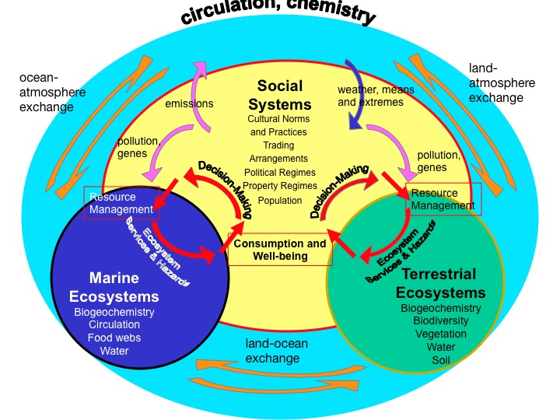

*Figure 6. Source needed\*\*\**

When large or complex observatories are being designed, quantitative modeling may be required to complement conceptual modeling. For example, specification of replication or accuracy requirements may need a model of error propagation from observation to derived information in order to set design needs. In other cases, process model sensitivity analyses may be used to identify the most critical variables to observe over time. If an observatory is being used as a basis for forecasting, analysis of the (statistical or simulation) model can help identify the variables the most strongly affect predictions. The expense and complexity of Earth System observations are such that carefully worked out conceptual and numerical models are essential.

# 5.0 Key Questions

## 5.1 Definition of Research Questions

Detailed definition of the research questions that will be posed is beyond the scope of this paper, but it is important to note that questions will need to be formulated not only by Earth scientists, but also by social scientists. Engaging the social science research community up front, before developing system design and instrumentation, will be critical for ensuring the full collaboration of this community. Although not tailored to the development of a new integrated observing system (i.e., GOSHEN), a starting point for global environmental change resaerch questions of interest to the social science community is the Internationational Social Science Council’s “Transformative Cornerstones of Social Science Research for Global Change”(Hackmann and Saint Clair 2011) and the science plans for the resesarch programs of the International Human Dimensions Programme on Global Environmental Change Research (IHDP).

## 5.2 Detection and Attribution

The assessment of Earth System sustainability requires the detection and attribution of change within that system, in particular in the context of ecosystem services (Millennium Assessment, 2005). Characterisation of the uncertainty and the spatial-temporal resolution over which such change is important as well as the coupling across scales are fundamental to any such assessment. To approach this requires consideration of the following questions and the development of an observing system that can provide the answers:

1. What must be measured to assess the current trend of economic, ecological and social conditions thought to underpin Earth System sustainability?
2. How do we measure those aspects of socio-ecological systems that are precursors to ecosystem services?
3. What are the observables needed to understand the consequences of different actions or choices on the suite of ecosystems services (provisioning, cultural, regulating and support) e.g. trade-offs between food production and biodiversity, biofuels and food production.
4. What must we measure and monitor to detect and understand:

the impacts of the GEC on human well-being and activities?

the impacts of human activities on GEC?

the impacts of human adaptive responses on GEC?

## 5.3 Analysis and Forecast

The detection and attribution of change on its own is not sufficient and there is a need to establish the sign, rate, duration and strength of any such change and, given that information, assess the consequences in terms of the future evolution of the Earth System on timescales relevant for policy and management. In a similar fashion to detection and attribution the reliability of any projection requires characterisation as well the multiple temporal and spatial scales over which any projection has value. The following key questions that arise in this context are:

1. What are the values of the key parameters of the Earth System that govern its evolution over time?
2. What is the current state of those aspects of the Earth System that govern its future on decadal-centennial timescales?
3. What are the most important variables to observe in order to assess projections?

## 5.4 Scenario Building and Decision Support

The detection, attribution of change and evolution of the Earth System provide the basic scientific observations on which evidenced-based policy can be formulated. However, there is a need to translate these scientific observations into information relevant to policy and decision-making apparati. This requires the distillation of the scientific view of the Earth System and its sustainability into the language and temporal-spatial scales of the policy world. The following questions thus need to be addressed:

1. How can we best communicate the information from observing systems to inform policy?
2. What observational information is needed to inform policy decision-making:

How much information?

What degree of certainty?

What spatial and temporal scales are relevant?

1. What must be measured to assess the likelihood of societally relevant tipping points in the Earth System e.g.:
   1. Changes in the probability of extreme events
   2. Water scarcity
   3. Permafrost degradation as affecting infrastructure
2. What do we need to know to assess the large-scale efficacy of environmental management?

# 6.0 Requirements

Key requirements must be defined in order to achieve the Merton Initiative goal and objective (above). The requirements were developed to help guide the eventual planning of a human-environment observatory, responsive to the questions and findings described above.

Some of these requirements are common to many or most observing systems, while others are specific to the need for a system that can detect, attribute and support forecasting of the coupled human-natural system. Some of these requirements may be met globally or in certain regions with existing systems, while others may require the development of new capabilities.

Basic requirements:

* The observing system shall be free, open, and interoperable
* The observing system shall collect data and provide information on the Earth System at a scale that is suitable to advance science and inform policy and management.
* The observing system shall provide usable information from its observations to enable its access and use for education, scientific discovery, and to inform policy and management.
* The observing system shall produce data with the appropriate temporal and spatial resolution, extent and duration, accuracy, and precision to allow detection, attribution, and forecasting
* Standardization of information products in a global context is required, to allow common information to be drawn from a globally distributed network of sites.
* Data collected and archived to allow aggregation and disaggregation in a consistent and traceable manner e.g. in situ measurements should be collected to allow calibration and validation of space-based observations used for extrapolation.
* Data shall be traceable with provenance and include characterization of uncertainty.
* The observing system shall provide the observations of Earth System drivers and response that are required to establish the links between cause and effect as a basis for attribution and prediction
* Observations should allow the detection and attribution of interactive processes at multiple scales e.g. a farmer’s decisions are influenced by global commodity prices and local environmental conditions, such as soil moisture.
* The priority will be to establish observing systems in data-poor regions with high Earth System impact, to maximize the science value for each increment of new data.
* The system shall be designed with human and technological capacity building as a priority.
* The system should be flexible and adaptable to changing questions, scales, conditions and technology to allow for decadal-centennial operation.

# 7.0 Implementation Options

To build an inclusive, useable strategy that promotes action, all users need to be engaged from the outset and existing networks must be harnessed. This means working in partnership with other physical and social science observing networks, both global and regional, and with different funding sources and users.

While linking existing networks and observatories is a critical need, it is not sufficient for creating a global integrated environmental observing network. It will also be necessary to add sites/observations in under-sampled regions, to augment with co-located human, physical and biological measurements, and to develop new methodologies for integrating such measurements into higher-level data and information products. Creation of a suite of new terrestrial observatories in under-sampled areas that integrate in situ, airborne, and satellite measurements with economic data, health data, surveys, and interviews is a significant near-term opportunity.

* Research and planning towards an integrated human-environment observing paradigm is critical, and should be a focus on GEOSS and Future Earth efforts.
* Identification of important Earth System regions where lack of observations contributes to critical uncertainty should be formalized and scientists, funders, national and international organizations such as GEOSS should continbually seek to fill these gaps in a coordinated fashion,
* Space-based data are critical for understanding global and globally-distributed processes. New and improved technical and programmatic strategies for coordinating in situ and space based observations are needed to ensure a continuing increase in the value of global data products.
* In addition, as new Earth System interactions come into scientific focus, innovative data products (together with next-generation sensors in orbit) should contribute to the evolution of in situ calibration, validation and algorithm development studies in the observatory framework.
* Feedback from international programmes such as GEOSS to the IGBP and partner activities also represents a great opportunity for gap analyses in those programs to be acted upon through the international programme’s global on-the-ground participants.

We have stated our intention to engage with people, programmes, projects and networks that share our goal (see 2.0). This process started at the initial meeting and we will continue to extend and engage with more diverse people throughout the iterations of the strategy document, through to its implementation. This may include IT, data visualization scientists, and young scholar networks.

To be truly sustainable and to engage developing countries, observation networks must support the development agenda. The observation network can help to build infrastructure for science establishments as well as using the observations to managing and monitor the natural environment.

They also need sustainable funding mechanisms, perhaps based on the Observatory model described earlier.

………….

# References

Birdsey, R., N. Bates, M. Behrenfield, K. Davis, S.C. Doney, R. Feely, D. Hansell, L. Heath, E. Kasischke, H. Kheshge, B.E. Law, C. Lee, A.D. McGuire, P. Raymond, C.J. Tucker. 2009. Carbon cycle observations: Gaps threaten climate mitigation policies. EOS Transactions 34:292.

Bombelli, A., V. Avitabile, H. Balzter, L.B. Marchesini, M. Bernoux, M. Brady, R. Hall, M. Hansen, M. Henry, M. Herold, A. Janetos, B.E. Law, R. Manlay, L.G. Marklund, H. Olsson, D. Pandey, M. Saket, C. Schmullius, R. Sessa, Y.E. Shimabukoro, R. Valentini, M. Wulder. 2009. Assessment of the Status of the Development of the Standards for the Terrestrial Essential Climate Variables. Report 67, Global Terrestrial Observing System. FAO, Rome. 18 pp.

Ciais, P., H. Dolman, R. Dargaville, L. Barrie, T. Battin, A. Bombelli, J. Butler, P. Canadell, T. Moriyama, A. Borgas, H. Boversmann, F.-M. Bréon, T. Battin, M. Bushwitz, R. Cook, N. Gobron, C. Heinze, M. Heimann, A. Held, M. Henry, E. Kasischke, B.E. Law, S. Luyssaert, G. Marland, J. Miller ,M. van der Molen, R. Munro, D. Ojima, Y. Pan, J.-D. Paris, S. Plummer, S. Quegan, P. Rayner, C. Sabine, D. Schimel, O. Tarasova, R. Valentini, A. Watson, G. van der Werf, C. Zehner. 2010. GEO Carbon Strategy. Geo Secretariat Geneva/FAO. Rome. 48 pp.

Hackmann, H., and A.L. St. Clair. 2011. “Transformative Cornerstones of Social Science Research for Global Change” (ISSC Draft Paper, November 2011). Available at <http://www.icsu.org/future-earth/transition-team/meetings/2nd-transition-team-meeting/documents-1/ref-7-issc-climate-change-design-project>

Law, B.E., T. Arkebauer, J.L. Campbell, J. Chen, O. Sun, M. Schwartz, C. van Ingen, S. Verma. 2008. Terrestrial Carbon Observations: Protocols for Vegetation Sampling and Data Submission. Report 55, Global Terrestrial Observing System. FAO, Rome. 87 pp.

Lee, X, M.L. Goulden, D.Y. Hollinger, A. Barr, T.A. Black, G. Bohrer, R. Bracho, B. Drake, A. Goldstein, L. Gu, G. Katul, T. Kolb, B.E. Law, H. Margolis, T. Meyers, R. Monson, W. Munger, R. Oren, K.T. Paw U, A.D. Richardson, H.P. Schmid, R. Staebler, S. Wofsy, L. Zhao. 2011. Observed sensitivity of local climate to deforestation in mid- and high latitudes. Nature. DOI:10.1038/nature10588.

Martin, L.J., B. Blossey, and E. Ellis. 2012. Mapping where ecologists work: biases in the global distribution of terrestrial ecological observations. *Frontiers in Ecology and the Environment*. 10(4): 195-201. DOI: 10.1890/110154

Millennium Ecosystem Assessment, 2005. *Ecosystems and Human Well-being: Biodiversity Synthesis*. World Resources Institute, Washington, DC

National Research Council. 2010. Verifying Greenhouse Gas Emissions: Methods to Support International Climate Agreements. National Academies Press, Washington, DC. ISBN: 0-309-15212-7, 124 pages.

Teuling, A.J., Seneviratne, S.I., Stöckli, R., Reichstein, M., Moors, E., Ciais, P., Luyssaert, S., van den Hurk, B., Ammann, C., Bernhofer, C., Dellwik, E., Gianelle, D., Gielen, B., Grünwald, T., Klumpp, K., Montagnani, L., Moureaux, C., Sottocornola, M. and Wohlfahrt, G. (2010) Contrasting response of European forest and grassland energy exchange to heatwaves. Nature Geoscience, 3, 722-727.

# Appendix A. The Merton Initiative – Participants

ANDELMAN, SANDY Conservation International

BACKLUND, PETER National Center for Atmospheric Research

CHAVEZ, FRANCISCO Monterey Bay Aquarium Research Institute

COOK, ROBERT Oak Ridge National Laboratory

COX, PETER University of Exeter

DE SHERBININ, ALEX CIESIN, The Earth Institute at Columbia University

GREENWOOD, GREG Mountain Research Initiative

GUIBERT, GREG National Center for Atmospheric Research

HELD, ALEX CSIRO Office of Space Science and Applications

HIBBARD, KATHY Pacific Northwest National Laboratory

HOFFMAN, FORREST Oak Ridge National Laboratory

MONKS, PAUL University of Leicester/IGAC

NIGHTINGALE, JOANNE NASA GSFC

REICHSTEIN, MARKUS Max-Planck-Institute for Biogeochemistry

SCHIMEL, DAVID National Ecological Observatory Network/NCAR

SEITZINGER, SYBIL IGBP

SPEHN, EVA Institute of Botany, University of Basel/Diversitas

WALTERS, MICHELE GEO Biodiversity Observation Network (GEO BON)

PLUMMER, STEPHEN ESA

DOWNY, CAT IGBP/ESA

# Appendix B. List of Observations Groups and Systems

|  |  |  |
| --- | --- | --- |
| **Biophysical Systems** | **Human Systems** | **Integrated Systems** |
| GEO BON  ILTER  GEO/GEOSS  GTOS  GCOS  GOOS  GFOI (Global Forest Obs Initiative)  FLUXNET  Argo  OCCP (Ocean climate, carbon)  TOGA  Global Atmospheric Watch  World Weather Watch  GRUAN  AERONET  OCEANSITES  ESA TIGER  NASA  NEON  AON  TEAM | Living Standards Measurements Survey (World Bank)  The UN initiative on Global Geospatial Information Management (GGIM)  WHO Health Surveilence Systems  Demographic and Health Surveys  Multiple Indicator Cluster Surveys (UNICEF)  Integrated Public Use Microdata Series (U. Minn.) | African Monitoring System (AMS) (Gates Foundation)  Multiple groups producing global spatial data from satellite and surveys (CIESIN/SEDAC, Univ. of Wisconsin/SAGE, U. of Minn./Institute for Env., McGill Univ.) |